**Module 3: Docker Part 1**

**Assignment – 4**

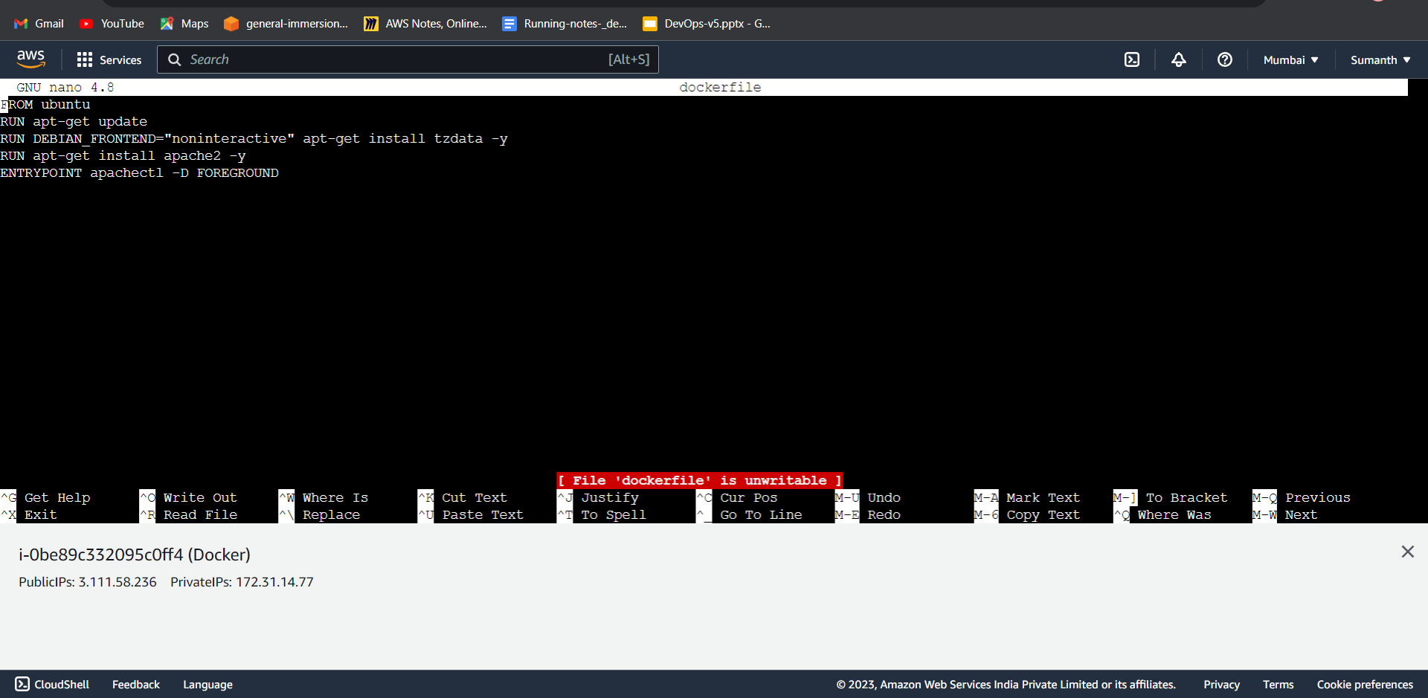

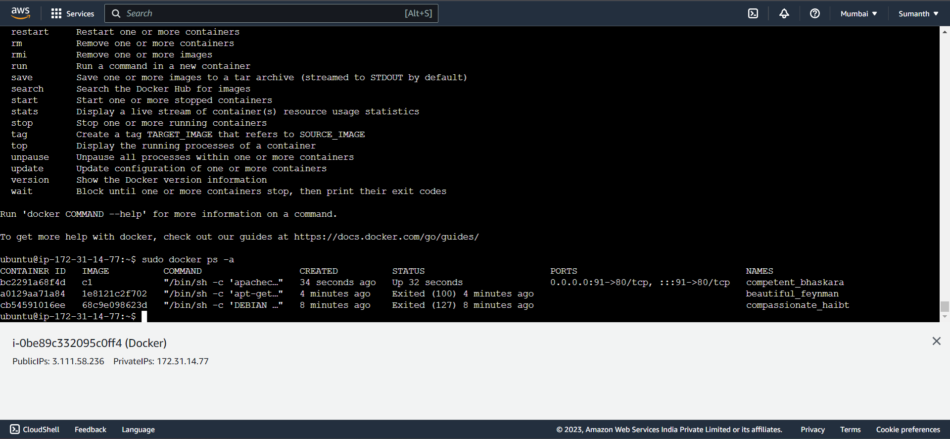

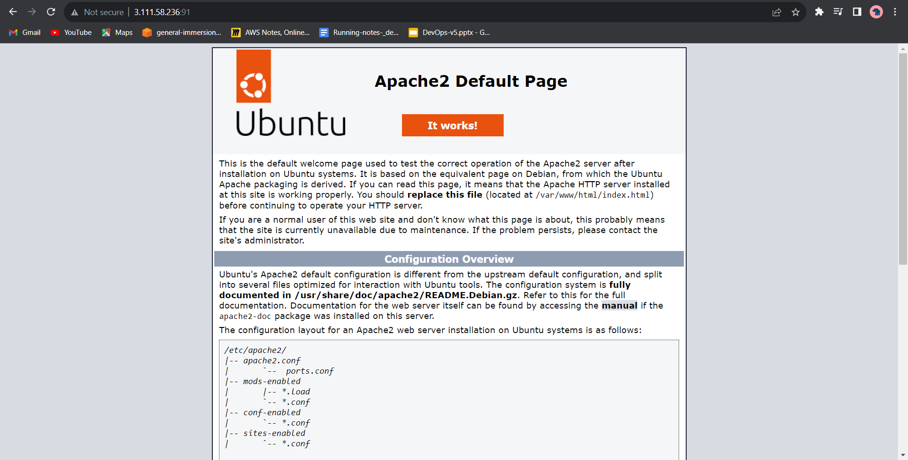

* Command used for the assignment

1 sudo apt-get update

2 sudo nano dockerfile

6 sudo apt-get install docker.io

7 ls

16 sudo docker build . -t c1

17 sudo docker images

18 sudo docker run -itd -p 91:80 c1

20 sudo docker ps -a